THE 7.62mm KAL 1 SELF LOADING RIFLE
HISTORY AND REASONS FOR DEVELOPMENT

L1A1 7.62 mm RIFLE

Background
- The L1A1 7.62mm Self Loading Rifle was developed by Fabrique Nationale just after the end of WWII and entered service in European Armies in the early 1950's. It was designed to satisfy the needs of warfare at that time but was far from ideal as it involved a number of compromises in an attempt to achieve some level of standardisation amongst NATO forces. The British at that time had built an innovative prototype which incorporated a “Bull-pup” butt configuration. (Of interest, when developing the L1A1, it is believed that FN also developed a prototype with a Bull-pup butt but for some reason did not proceed with it beyond a working model.)
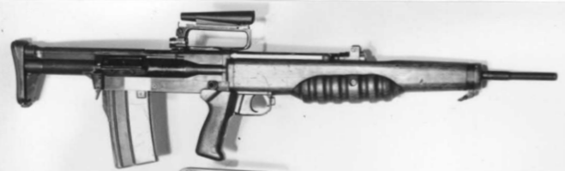Figure 1: EM2 Rifle Developed by British circa 1950
- Besides the innovation of a Bull-pup butt this rifle also featured a telescopic sight and a safety catch in front of the trigger (the significance of which will be discussed later). The downfall of this weapon apparently was the complicated and expensive method chosen for locking the bolt prior to discharge.
- Compared to the EM2 the L1A1 came a very poor second. It has many features that make it undesirable as a general purpose infantry weapon:
  - Balance. Unlike the classical hunting rifle where the balance is about the forestock, the infantry rifle should balance around the firing hand. The reasons why this is preferable are as follows:
    - Preparedness. In the interests of preparedness and control it is necessary the infantryman always hold the weapon by the pistol grip (firing hand) with the trigger finger outside of the trigger guard and the weapon on safe except in the case of the forward scout.
    - Ease of Carriage. The amount of exertion necessary to carry a weapon is related to the distance the centre of gravity of the weapon is from the body of the person carrying it; the further away it is, the more tiring the weapon is to carry.
    - Ease of Firing. By having the centre of gravity over the fulcrum of the wrist of the firing hand, the weapon is much easier to fire one handed whilst using the other hand to direct troops or hold onto something for the purposes of steadying oneself.
  - Versatility. Versatility comes in many forms:
    - Ambidexterity. It is necessary that an infantry rifle can be fired by left and right handed firers with equal ease. Even as, say, a right handed marksman, there will be times when one has to shoot around a left hand corner. In that situation, if the firer continues to operate the weapon right handed, they have to step out into the open, unduely exposing themselves, to take a shot.
    - Range of Engagement. To be a General Purpose weapon, it must be capable of being used in close quarters and in plains warfare where the range of engagement could be up to 600 metres (though 300 metres is the distance normally specified for most weapons these days). This has to be achieved without the need for additional sighting apparatus. Having said that, it would be preferable that the weapon, when fitted with a telescopic sight, was capable of being used as a sniper rifle. (Tests have verified that this is indeed possible with a semi-automatic weapon out to 600 metres; being able to consistently hit a stationary target the size of a human head from the lying prone supported position.)
    - Adjustability. The weapon has to be capable of being comfortably fired by tall or short persons without the need to fit a new butt. The butt length therefore needs to be adjustable.
    - Length. The length of the weapon must be such that it is suitable for close quarter combat and can fit into the close confines of a vehicle. This distils down to being as short as possible whilst still having the range needed to effectively neutralise an unprotected person at a distance of 300 to 600 metres.
    - Ease of Carriage. This relates to the shortness of the weapon and also its centre of gravity. As previously discussed, the centre of gravity is ideally just over the fulcrum of the wrist of the firing hand. The closer the centre of gravity is to the body of the firer, the easier it is to carry.
    - Calibre. The calibre of the round should be such that the round is suitable for use in an Infantry Section's light machine gun. In recent times there has been a move towards smaller calibres but higher muzzle velocities. This approach has not been found to be effective unless the projectile is designed to disintegrate or distort on impact. Rounds of this type are forbidden by the St. Petersburg Declaration of 1868 which then followed on to the Hague Convention of 1899, Declaration III, prohibiting the use in warfare of bullets that easily expand or flatten in the body. The Japanese used a calibre of 6.5mm in WWII and this was found to be deadly against humans. It was possibly this wartime experience that caused the British to opt for a 0.280” (7.1mm) calibre for the EM2. In deciding on the calibre of the weapon, there is also a decision to be made as to what is an acceptable weight of ammunition. The heavier the round, the fewer that can be carried. Given the US military doctrine for “prophylatic fire”, which is extragant in its use of ammunition, it is likely there was much pressure to adopt a calibre smaller than 7.62mm, the NATO standard, so that troops could carry far more rounds.
    - Weight. Weight of round brings us neatly to the question of the weight of the weapon. A lightweight, high powered weapon will have a violent recoil. This can have the effect of making firers flinch and so contribute to inaccuracy. The recoil of the L1A1 is severe and is made more so as a result of the poor design of the stock which tends to bruise the cheeks of many users. Of interest the longer the barrel, the less rapid is the acceleration of the projectile to reach its terminal velocity when exiting the weapon. This reduces the recoil and so allows for a lighter weapon for any given projectile energy. The suggested maximu weight of an infantry weapon is around 9 pounds or 4.1 kgs.
    - Killing Capability. The matter of lethality of a round has been touched upon when discussing the calibre. For humans, the most effective round is a “.303/.25”. This is a common round used for hunting kangaroos in Australia. It is named because it has a .303” sized case and a .25” diameter projectile. The muzzle velocity is around 3,000 feet/second (914 metres/second) so the trajectory is very flat and the accuracy is not much affected by crosswind. In the case of a military round there is another dimension and that is the ability of the round to penetrate cover. Light, high velocity rounds slow down rapidly when they hit leaves or long grass. The 7.62 mm round on the other hand plows it way through. Test conducted by me showed that the L1A1's round had the capacity to penetrate around ½ a metre (22”) of high quality pine at 25 metres (27 yards). In other words, a person seeking cover behind a tree had better choose a thick one!
    - Rate of Fire. In the case of the L1A1, infantryman usually carry 120 rounds as their “first line”. In a contact it is possible to exhaust this in a few minutes if the person lacks discipline. Once exhausted, resupply is a problem if the enemy maintains contact. Although automatic fire can be useful for an initial wild burst, it is not prudent to continue with that practice as the contact progresses. Instead the ammunition must be rationed to aimed shots. Requiring an infantry weapon to be capable of prolonged automatic fire is fanciful unless the person is defending a perimeter from a fixed position; something that is, itself, extremely hazardous.
- Why Calibre Doesn't Matter when Prototyping. The significant part of the foregoing discussion has dwelt upon the calibre of the round to be fired. That is because, the rifle is really the interface between a firer and the round being fired. Calibre of a weapon should therefore not be a major consideration in the initials stages of designing a weapon. The fact is, there are many different types of locking mechanisms and most of these can accommodate a wide variance in calibre size. The AK-47's locking system is by far the best of any modern weapon. It is the best because it is extremely simple and it is self purging. Any detritus in the body or chamber is effectively wiped out of the way by this bolt with each chambering of a new round. The large single locking lug is relatively easy to fashion in a vice and file; the reason why many AK-47s have been successfully fabricated in crude workshops in South East Asia and the Middle East. Other locking mechanisms such that which is found on the M16 sit at the other end of the spectrum of suitability for an infantry weapon. They are not self-cleaning because the dirt has no where to escape to. They are prone to jamming, have fine tolerances and require specialist, expensive machinery to fabricate. Related to the bolt head is the manner in which the round is ejected. In the case of the L1A1 and the AK-47, there is a stationary ejector. In the case of the M16, there is a spring loaded pin to eject the round. This has a number of disadvantages. Firstly it is expensive. Secondly, the round commences ejection the moment it clears the chamber. Lastly, it is something that can jam or fail and so lead to a weapon stoppage. In summary, when prototyping, the calibre doesn't matter. When the KAL 1's predecessor, the RMC No2, was being assessed, there was some criticism of the fact that it used a 7.62mm round. It did this because the weapon was expediently made from L1A1 parts. It would be a simple matter from an engineering perspective to recalibre the weapon to a smaller calibre and to use a different locking mechanism to that which is used in the L1A1.

THE KAL 1 DEMONSTRATOR
Seeking a Shorter Rifle
- The KAL 1's development was initiated by the need for a shorter rifle, the need for which was exemplified by:
  - SASR (Special Air Services Regiment)'s crude attempts, with RAEME assistance to shorten the L1A1 in Viet Nam by cutting the barrel off near the gas plug, shortening the butt and placing an extra pistol grip along the forestock for better control on automatic fire. This resulted in a less powerful, less accurate weapon with a large muzzle flash. The fact that many preferred this weapon to the Armalite (Colt M16A1) and it round is enough comment on the lack of esteem with which that weapon was held!
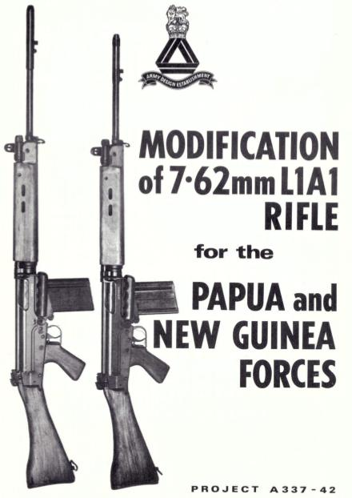Figure 2: PIR Rifle by ADE
  - Another example was the shortening of the L1A1 by about 4 inches (100mm) by Army Design Establishment (ADE) (See Figure 2) for use within the Pacific Islands Regiment by soldiers who were typically much shorter than the average Australian soldier. This was achieved by reducing the butt length and shortening the flash eliminator. The shorter flash eliminator turned the muzzle blast at a sharper angle, supposedly reducing recoil. As it was, the L1A1's flash eliminator produced an ear damaging blast. This modified flash eliminator was much worse.

Possibilities for Achieving a Shorter Length
- General Considerations. It was thought because of these examples and because of extensive experience gained on exercises in thick coastal forests and bushland that a shorter rifle would be of great benefit to the soldier. To shorten the rifle required reducing the barrel or the butt or both.
  - Reducing the Barrel Length. Reducing length of the barrel had the following issues:
    - decreased accuracy,
    - lower lethality because of a lower projectile velocity, and
    - increased flash if using standard 7.62mm ammunition designed for a longer barrel.
  - Reducing the Butt Length. The ability to reduce the length of the butt of the L1A1 is limited because it houses the return spring. If a major redesign was acceptable, the return spring could be located in a hollow piston which would be an integral part of the breech block slide (as is the case in the AK-47). Reducing the butt then becomes a possibility but once again, because of ergonomics, there is a limit as to how close the pistol grip can comfortably be to the firer's shoulder.
- The Bull-pup Butt Option. In order to keep the barrel the same length (or even make it slightly longer) and reduce the length of the weapon significantly, the obvious option is to remove the conventional butt completely and put the pistol grip ahead of the magazine so as to provide a reasonable distance between the shoulder and the firer's hand. This approach necessitates the return spring being located inside the gas piston (as is the case with the AK-47) or at least running up the side of the barrel.

Building a Bull-pup Butt Working Mockup
- Plans were drawn up for this in December 1969 and January 1970. By May 1971, support had been gained by way of the patronage of:
  - the Scientific Advisor, Mr Max Nesbitt,
  - the Chief of the General Staff, Lieutenant General Sir Thomas Daly, and
  - Mr Eric Duve, the Department of Supply, Mr Eric Duve,
- A working mockup, using L1A1 parts and drawings professionally produced by the Department of Supply, was completed in mid-August of 1971 at the Small Arms Factory Lithgow. It was designated the RMC No2 (the original plans being RMC No2) and is shown in Figure 3.

- Over a period of one and half years, the RMC No2 was carried for about 12 weeks on navigation exercises and in Infantry Minor Tactics training conducted in terrain varying from flat savannah plains to thick, mountainous coast scrub and forest. In 1973, it was taken to Jungle Training Centre where it favourably impressed the training staff at Battle Wing. Within that two years, the rifle fired many thousands of rounds of live ammunition as well as blanks. As a consequence of this experience a number of things became apparent:
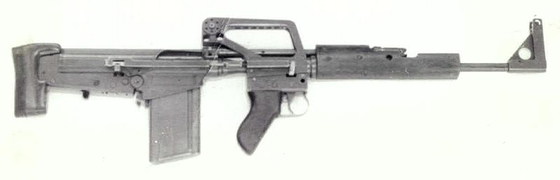Figure 3: RMC No2 Manufactured at SAF Lithgow, Apr-June 1971
  - The centre of gravity of the weapon was just behind the hand and this made it very easy to carry and quickly manoeuver into a firing position. Because the rifle is so close to the body, it can be rested on a basic pouch which further added to the ease of carrying the weapon.
  - Because of the RMC No2 is short (approx 32” or 70cm), it is extremely easy to move in close country or in buildings and narrow corridors. Although the foresight is prominent, it never became entangled; most probably because it was always close to the body and the non-firing hand would be moving aside the vegetation as a matter of course as the soldier made his/her way through the under-growth.
  - The rifle could be fired left handed because the ejected cartridge flies forward at an angle to the ejection port. Nevertheless, it was intended with a future prototype to arrange for the cartridge to be guided downwards by the curve of the ejection port of the breech slide cover. In such an arrangement it would be possible, if desired to have a bag to catch the cartridge so that no produce was left at the firing site. This was seen to be an advantage in some situations.
  - The RMC No2 was found to be extremely accurate. Far more accurate than the L1A1 for the following reasons:
    - The rifle having its CG nearer to the body of the firer and being shorter is more stable and less fatiguing in the aiming position.
    - The sight length is the same as the L1A1 but, unlike the L1A1, there is no flexible hinge between the foresight and the rear aperature sight.
    - The firer can adopt an unconventional pose where the firing hand is held in the cup of the other hand which is rested directly on the ground as shown in Figure 4. This is the result of the CG being behind the pistol grip and the distance between the shoulder of the firer and the pistol grip is around 20% longer than is the case with the L1A1. The support point is thus almost half way between the points that a firer would hold a conventional rifle, ie, one hand on the pistol grip and one on the forestock as can be seen in Figure 4.
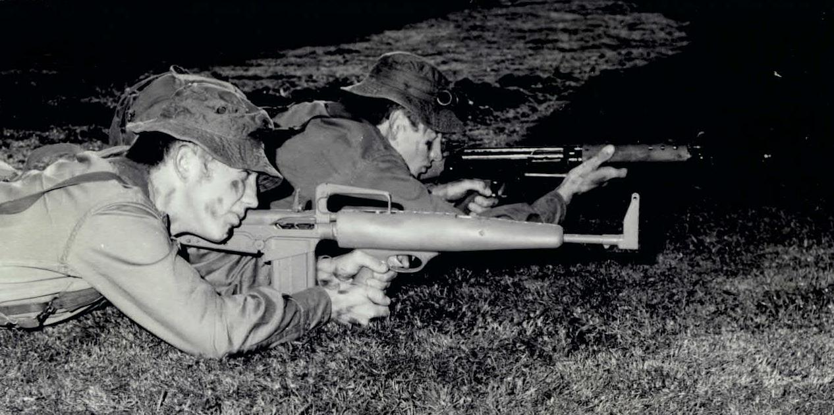Figure 4: Firing Left Handed in the Lying Unsupported Position
- In the position shown in Figure 4 it was possible to consistently detonate a 38mm “Whizz-bang” at 100 metres and hit a 4 litre can of paint (approximately the size of a human head) at 300 metres. With a scope fitted, as shown in Figure 5, it was possible to consistently hit a 4 litre can at 600 metres.
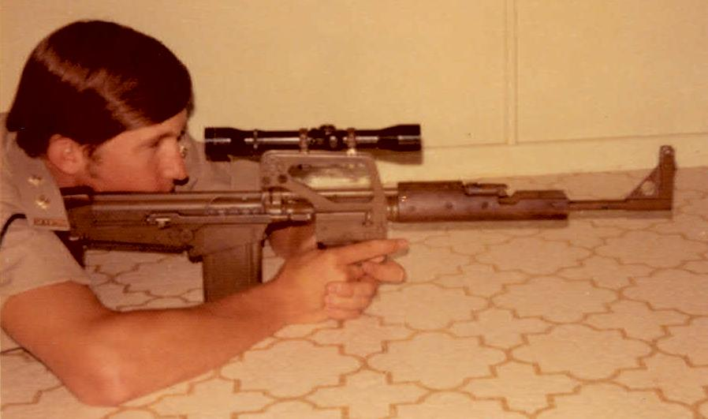Figure 5: RMC No2 Fitted with Sniper Scope

